Lecture 13:
-Deep Water Circulation
-Thermohaline circulation
-Temp-Salinity
-Abyssal circulation
-Meridional overturning circulation
-Global conveyor belt
-Thermocline
-An area of the ocean where there is a lot of change in the temperature of the ocean

-Halocline
-High salinity in the bottom of the ocean, salt has a higher density
-Pycnocline
-High density at the bottom because of salinity and temperature
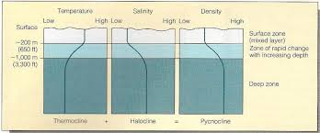
-Source of Deep Water
-Low latitude
-High latitude
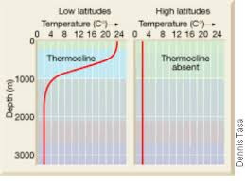
-Warm Water acts like a lid and does not allow for mixing and deep water formation
-Driving forces: Wind cools surface water (decreases temperature), evaporated water vapor (increase salinity)
-Importance of deep water circulation
-Vertical stratification: Important in dynamics and biology
-Heat transport influences earths heat budget and climate
-It provides dissolved oxygen to the deep ocean
-Holds off the effect of climate change by being a carbon sink
Water masses: parcels of water exhibiting somewhat narrow range of temperature and salinity
-Layers of ocean currents are defined by temp. and salinity
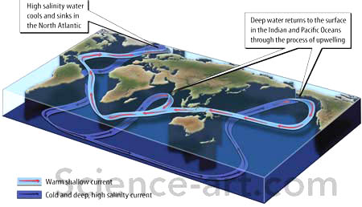
-Two main areas of deep water production at the poles
-Very little deep water formation in the pacific because there is low salinity and lots of freshwater input
-Argo floats
-Track salinity and temperature
-Are neutrally buoyant
-Global effort
-Tracers
-Chemical, Nutrients, and radiation
-Based on when they were used you can learn about how the concentrations change in the water column
-Glacier melt
-Decreases salinity of the ocean
-Fresh water lens would stop deep water formation
Lecture 14:
-Waves are moving energy
-Most waves are wind driven
-Moving energy along ocean/ air interface
-Wind main disturbing force
-Boundary between and within fluids of different densities
-Air/ocean interfaceOcean waves
-Air/ air interface Atmospheric waves
-Ocean/ ocean interface Internal waves
-Splash waves: from surface disturbance/ displace
-Only effects surface of water
-Seismic wave/ Tsunami: seafloor movement
-Effects entire water column
-Wakes from boats
-Tides
-Sun and moon generated waves
-Tides
-24 hours
-Geologically generated waves
-Tsunamis/ seismic waves
-12 hours-6 minutes
-Wind generated waves
-Surface waves
-6 minuts-1 second
-Parts of a Wave
-SWL: still water level
-If there were no waves
-Crest
-Peak of wave
-Trough
-Lowest point of wave
-Wave Height
-Crest to trough
-Wave Length
-Crest to crest
-Wave Period=T
-The time it takes for a full wave or wavelength to pass a fixed position
-Typically 6-16 seconds but can range as long as 24 hours
-Wave frequency=f
-f=1/T
-Number of waves passing a fixed location per unit time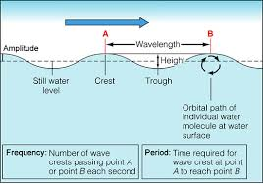
-Water doesn’t move in a wave, only the waveform moves
-Wave Motion:
-Transmit energy
-Cyclic mortion of particles in the ocean
-up and down
-back and forth
-Body waves
-Longitudinal waves
-Push pull waves
-Particles move back and forth in a horizontal direction
-Transverse waves
-Side to side waves
-Particles move at angles to direction of energy transition
-Energy transmitted by vibration
-Transmits energy through solids
-Surface waves
-Orbital waves
-Particles moving orbital path
-Energy transmitted along interface between two fluids of different density
-Circular orbits of an object floating at the surface have the same diameters as the wave
-Wave Base
-Gets smaller as it goes down the water column
-Equal to one half the wavelength (at swl) or L/2

-Deep-water waves
-The water depth is greater then the wave base
-Water column is deep enough for the wave not to disturbed the bottom of the ocean
-Shallow-water wave
-Water depth is 1/20L or less
-Wave base interacts with bottom
-Transitional waves
-Water depth above 1/20L but less than ½ wave length
-Has some interaction with the bottom but not as much as shallow-water waves
-Wave Speed
-S= wavelength (L)/ Period (T)
-More correctly known as Celerity used only in relation to waves where no mass is in motion, just the wave
-When waves meet
-Constructive interference
-Waves in phase: crests and troughs match up results in larger waves
-Deconstructive interference
-Waves out of phase: crests and troughs to not match up results in smaller wave
-Mixes Interference
-Waves of different periods and length results in mess
-How do you build a big wave?
-Wind speed
-Duration: how long the wind blows in one direction
-Fetch: Distance it blows in one direction
-Wave development
-Capillary waves
-Gravity waves
-Waves breaking
-Wave breaks when steepness (wave height H/ wavelength L) > 1/7
-Wave Steepness= H/L
-1/7 ratio gives limitations for waves
-Biggest waves are around Antarctica because there is no land to disrupt the waves and gives perfect conditions for large waves
Lecture 15:
-Wave steepness 1/7 rule dictates maximum wave height
-7m long can only be 1m high
-14m long 2m high
-Beaufort Wind Scale and the state of the sea 0-12
-0: wind speed less than 1 knot, sea like mirror
-11: 56-63 knots wave height 11.5-16m covered by white sea foam
-12: wind speed 64 knots sea completely white with driving spray
-How big can a wind generated wave me?
-About 60 ft
-Three categories of freak waves
-“Walls of water” travelling up to 10km through ocean
-“Three sisters” Groups of three waves
-Single, giant storm waves building up to fourfold the storms waves height and collapsing after some seconds
-Draupner wave
-Single giant wave measured New Years Day 1995
-In the Open Ocean
-1 in 23 will be 2x as high
-1in 1175 will be 3x as high
-1 in 300000 will be 4x as high
-Truly big- 1 in several billion
-Wave Energy
-Fully Developed Sea
-Maximum wave height, wavelength fir particular fetch, speed and duration of the winds at equilibrium conditions they lose energy through the breaking as fast as they gain energy in wind
-Swell
-Waves preceding a storm, consistent
-Ground Swell- Deep ocean swell one that might be generated by a distant storm or earthquake.
-Wind swell not as long coming. Starts closer to shore
-As waves approach shore
-Wave speed decreases
-Wavelength deceases
-Wave height increases
-Wave steepens increases
-Wave breaks
-Brakers in surf zone
-Spilling breaker
-Water slides down front slope of wave
-Gently sloping seafloor
-Wave energy expanded over a long distance
-Plunging breaker
-Curling crest
-Moderately steep seafloor
-Wave energy expended over shorted distance
-Best for board surfers
-Surging breaker
-Breakers of shore
-Steepest seafloor
-Energy spread over shortest distance
-Best for body surfing
-Why is it better to surf on the west coast vs. the East?
-Steepness of the coast
-Wind blows toward show
-Tsunami or seismic sea wave
-What are they?
-Sudden changes in seafloor caused by earthquakes, submarine landslides, volcanic eruptions
-Effects entire water column
-Long wavelengths
-Considered shallow water waves
-Fast
-Sea level rise up to 40 m when tsunami reaches shore.
-What do they do?
-Mostly in Pacific Ocean
-Causes lots of damage
-People die
-Wave speed: square root of Gravity/Depth
-Sometimes around 540 mph
-Can be used to help evacuation and preparation
Lecture 16:
What is a Tide?
-Rhythmic rise and fall of a sea level
-Very long and regular shallow- water waves
-Caused by gravitational attraction of the Sun, Moon, and Earth
-Different tides in different places.
Tide-Generating Forces:
-Earth and moon orbit together around the Sun
-Barycenter between moon and Earth
-Earth rotation 24 hours
-Moon rotation 24.7 hours
-Gravitational pull between all objects
-F_{g}=(Gm₁m₂)/r²
-G=Gravitational Constant
-If mass increase, gravitational force increase
-If distance increases, gravitational force decreases
-Zenith: closest point to mass
-Nadir: farthest point from mass
-Moon has a larger impact on tides than the Sun
-Resulting forces: differences between centripetal ad gravitational force
-Tide-Generating forces are horizontal components
-Tidal Bulges:
-In perfect, smooth earth, no continents
-Small horizontal forces push seawater into two bulges
-Opposite sides of earth
-One bulge faces moon
-Other bulge on other side of earth
-Two tidal bulges
-Two high tides about 12hours apart
-High tide, flood tide, seawater moves on shore
-Low tide, ebb tide, seawater moves off shore.
-Lunar Day:
-Moon orbits earth
-24 hours 50 minutes rotation
-Earth-Moon-Sun position Spring and neap tides
-Spring tides: very big tide
-New or Full moon
-Tidal range greatest
-Neap tides: very small tide
-Quarter moons
-Tidal range least
-Monthly tidal cycle
-Height of tides affected by moons location in relation to the earth
-Earth and moon are not at a perfect angle (tilt)
-Moon around earth
-Tidal range greatest at perigee
-Tidal range least at apogee (moon farthest from earth)
-Perigee - apogee cycle 27.5 days
Earth and Sun
-Tidal rage greatest perihelion (Jan) and perigee
-Tidal range least at aphelion (July) and apogee
Real tides:
-Earth not covered completely by oceans
-Continents and friction with seafloor modify tidal bulges
-Tides are shallow water waves with speed determined by depth of water
-Tidal bulges can’t keep up with earths rotation
-Instead large circulation cells in the ocean basins dictate how tides form in different oceans.
-Tidal cells in World Ocean:
-Crests and troughs of tides rotate around the Amphidromic point
-No tidal rage at point
-Cotidal lines: connect simultaneous high tide points
-Tide waves rotate every 12 hours
-Move at a speed of 1600 km/hour
-Tidal Patterns
-Diurnal
-One high tide and one low tide per day
-Tidal Period 24 hours 50 minutes
-Semidiurnal
-Two high tides and two low tides per day
-Tidal range about the same
-Tidal period 12 hours 25 minutes
-Mixes
-Two high tides and two low tides per day
-Tidal range different
-Tidal periods around 12 hours 25 minutes
Lecture 17:
-Ecology: the study of organisms at “home”
-The study of the inter-relationships between the physical and biological aspects of the environment
-How the organisms adapt and change to the environment
-What’s life?
-Adapts to their environment
-Change through time
-Capable of reproduction
-Capture, store, and produce energy
-Two marine provinces
-Pelagic Zone: water column
-Benthic Zone: bottom
-Really shallow to really deep
-Define ocean by depth
-Pelagic divisions:
-Epipelagic: surface- 200m
-Mesopelagic: 200-1000m
-Bathypelagic: 1000-2000m
-Abyssopelagic: 2000-6000
-Hadalpelagic: 6000m or greater
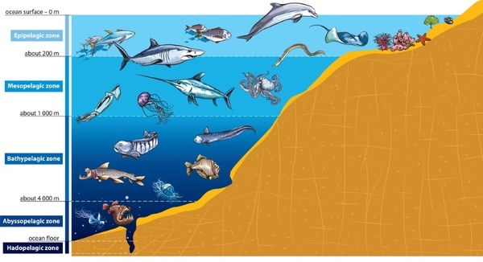
-Light divisions:
-Photic zone: surface-100m
-The depth where light is sufficient for photosynthesis
-99% of photosynthesis happening here
-Dysphotic zone: 100-480m
-The depth where illumination is too weak for photosynthesis
-Aphotic zone: 480m-bottom
-The depth where no light reaches because it has all been absorbed by the water above it.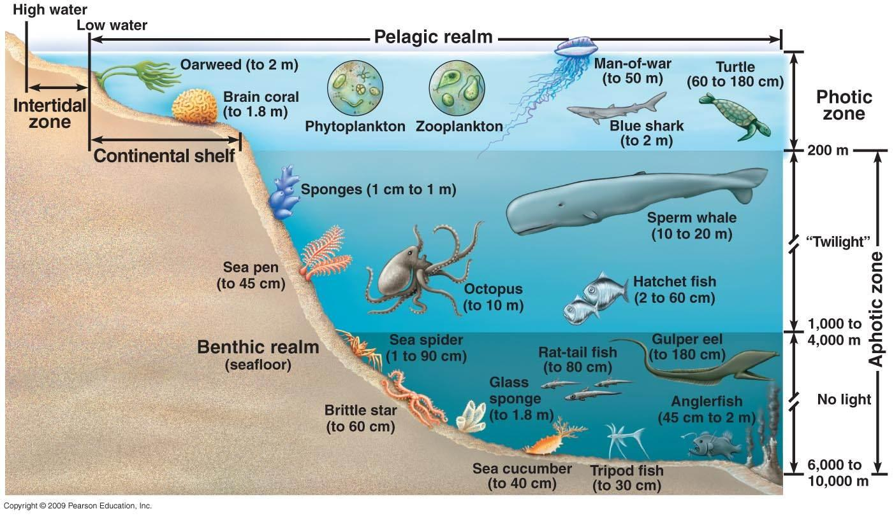
-How many species live in the ocean?
-Over 250,000
-Scientist say many many more
-In 1735 Linnaeus developed the taxonomic classification used in zoology
-Categorized from largest to smallest
-Domain
-Kingdom
-Phylum
-Class
-Order
-Family
-Genus
-Species
-The name of the species consists of the Genus and species
-Kingdoms
-Monera: bacteria, including cyanobacteria and archaea
-Protista: single or multi celled organisms with a nucleus; single celled algae (phytoplankton) or animals
-Fungi: abundant in the intertidal zone and are important in decomposition 100,000 species of molds but over all few in the ocean
-Plantae: plants free floating or attached
-Anamelea: all multicellular animals (sponges to whales)
-Domains: 3 domains
-Prokaryote: no organelles or nucleus
-Separated into Bacteria and Archaea later on
-Archaea: have a flagella structure, different ribosomal structure, type of linkage of their lipids, structure of cell covering and Eukaryote like DNA. They often are found in extreme environments.
-Eukaryote: has nucleus and membrane bound organelles
-Bacteria: unicellular organisms
-All bacteria are prokaryotes
-Normally microorganisms not visible to the human eye
-Marine Genomics
-Hot topic in marine science because you can learn a lot about how an organism is functioning
Lecture 18:
-Classification of Marine Organisms by mobility
-Plankton (floaters)
-Cannot direct their movement in the ocean
-Nekton (swimmers)
-Swim and Move actively
-Benthos (bottom dwellers)
-Pelagic Plankton
-Viruses
-Bacteria
-Phytoplankton
-Zooplankton
-Pelagic Nekton
-Squid
-Fish
-Types of Plankton
-Autotroph Phytoplankton
-Heterotroph Zooplankton (eats autotrophs)
-Most biomass on earth consists of plankton
-Phytoplankton
-Autotrophic can photosynthesize and produce their own food
-Zooplankton
-Heterotrophic relies on food produced by others
-Bacterioplankton
-Very small
-Can photosynthesize
-At least half of the oceans photosynthetic biomass
-Likely the most abundant photosynthetic organism
-Viroplankton
-Extremely Small
-Not well understood, may limit abundant of other plankton through infection.
-Holoplankton
-Entire lives as plankton
-Meroplankton
-Part of lives as plankton
-Juvenile or larval stages
-Squid’s juveniles are plankton
-Macroplankton
-Large floaters such as Jellyfish
-Picoplankton
-Very small floaters such as bacterioplankton
-Benthos
-Epifauna live on surface of seafloor/benthos
-Infauna live buried in sediments
-Nektobentos swim crawl though water above seafloor but spend most of their time on the surface of the seafloor.
-Most abundant in shallower water
-Depend on food trickling down from surface
-Many live in darkness, stillness, coldness, and under high pressure
-Ocean Primary Production
-Less in Gyres, warmer waters
-More on coastlines, freshwater deposit zones, colder water, equator, upwelling areas
-47% of Global Primary Production is from the ocean
-Only accounts for 0.2% of the earth’s biomass
-Phytoplankton Grass of the Sea
Lecture 20:
-Primary Production by Phytoplankton
-Respiration: Organic Matter +O₂ CO₂ + NO₃ + PO₄ + H₂O
-Consumes oxygen
-Creates nutrients
-Marine Snow
-Sinking particles
-Poop + Dead Stuff
-Contains surface CO₂
-Oxygen and Nutrients
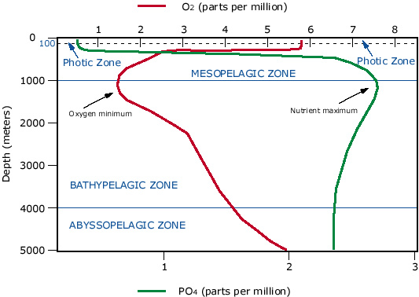
-Process of Photosynthesis happens at the surface
-Increase in oxygen at bottom because of thermohaline circulation
-100m peak driven by respiration
-Phytoplankton Bloom
-Mass abundance of Phytoplankton, noticeably larger
-Attracts larger ocean organisms
-Good for productivity at base of food chain
-Can be bad and cause dead zones
-Sverdrup’s Model of Critical Depth
-Photosynthesis exponentially decreases in light availability.
-Respiration is unaffected by light and remains constant with depth
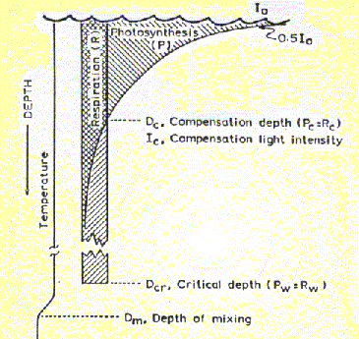
-Compensation point: rate of photosynthesis = rate of respiration (ideal for production)
-Critical Depth point: Total photosynthesis = total respiration
-Low Latitude: strong thermocline stratified
-Hot buoyant surface layer that blocks upwelling
-High Latitude: very well mixed
-Lots of mixing and high winds
-Polar Oceans
-Nutrients are abundant due to vertical mixing
-Limited by sunlight
-Partially covered by sea ice
-Winter
-Low diatom
-Low zooplankton
-Spring
-High diatom
-Low zooplankton
-Summer
-Medium diatom
-High zooplankton
-Fall
-Low diatom
-Medium zooplankton
-Temperate Ocean
-Spring and fall blooms
-Delayed zooplankton bloom
-Nutrients fall during bloom and recover over the winter
-Tropical
-No big change throughout the year
-No bloom
-Low Primary Production as a whole
Lecture 21:
-Harmful Algal Blooms: HABS
-Nuisance bloom:
-Not harmful
-When they die oxygen levels lower
-When abundant
-Shading which blocks sunlight which means no photosynthesis
-Oxygen depletion from excessive respiration
-Mechanical irritation, damages fish gills
-Dinoflagellates
-Main algae in most cases
-Single celled
-Bioluminescent
-Harmful
-2 flagella
-6-8 million /L
-Red Tides
-Extreme Fish kills
-Toxic
-Brevetoxin: neurotoxin shellfish poisoning
-Domoic Acid: amnesic shellfish poisoning
-Cyanobacteria Toxins: Lots of different toxins that cause sickness.
-Pre 1972 vs Post 1972
-We look for it more
-Farm Runoff
-Sewage Runoff
-The Birds: Alfred Hitchcock
-Inspired by birds gone wild care in California in the 1960s
-Sea Birds vomiting and running into things
-Sooty Shearwaters
-Eat Anchovies that eat phytoplankton
-Pseudo-nitzschia bloom at the time
-Produce Demotic Acid
-Another Case in 2011
-Demotic Acid Biomagnification
-Energy flow in marine ecosystems
-Solar energy converted to chemical energy by Producers
-Consumers eat producers and other consumers
-Herbivores
-Omnivores
-Carnivores
-Decomposers eat the left over organic material
-Energy doesn’t cycle
-Nutrients do cycle
-Nutrient Cycle
-Nutrients Cycled from one chemical form to another (Fixing)
-Biogeochemical cycling
-Nutrients can be recycled through upwelling
-Trophic Levels
-Biomass decreases as you go from Producers carnivores
-Energy and nutrients are lost as you go though feces, respiration, and death
-Chemical energy is transferred from producers to consumers
-Only 10% of energy is transferred from one level to the next
-Very inefficient
-Food Chain
-Primary Producer Herbivore One or more Carnivores
-Food Web
-Branching Network of many consumers
-Consumers are more likely to survive with alternative food sources
-“Back up Plan” design, more options if something changes in the environment
-Biomass Pyramid
-Producer carnivore = Large biomass Small biomass
-1(killer whale) 10xmass (bonito) 100xmass (anchovies) 1000xmass (zooplankton) 10000xmass (Phytoplankton)

Lecture 22:
-CO₂ Concentration over time in the atmosphere
-Increases overtime
-Over 400ppm as of 2015
-Photosynthesis and Respiration
-Over the course of a year there is a high CO₂ point and a low CO₂ point because of the use of carbon throughout the year
-50x more inorganic carbon in the global ocean than in the atmosphere
-Solubility pump
-Thermohaline Circulation
-Gases go with the water
-Gas gets tapped in deep ocean water
-Gas exchange allows CO₂ to enter ocean
-Flux depends upon air-sea CO₂ difference
-Solubility increases in cold water (polar regions are sinks and equatorial regions are sources)
-Sinks and sources are not uniform in location
-Biological Pump
-Carbon gets trapped in phytoplankton
-When they die they travel to the bottom
-Photosynthesis happening on the surface
-Lots of recycling
-Particles slowly fall to the bottom and carry nutrients and CO₂
-Pathways for rapid Carbon sequestering
-Turn off Biological Pump would increase atmospheric CO₂ by 200 ppmv
-What Controls Carbon Export?
-Primary Production high
-Carbon flux on sinking particles 100m (decade) 5-14%
-Carbon flux 1000m (centuries) 1%
-Carbon flux at bottom (millennium) 0.1%
-What controls phytoplankton?
-Temperature
-Light (solar angle and mixing)
-Major Nutrients (Carbon,Nitrogen, Phosphorus, Silica)
106-16-1-16 C-N-P-Si
-Grazing
-Minor Nutrients (Iron, Zink, other)
-High Nutrient, low chlorophyll
-Water Profiles show if elements are being biologically processed
-“Give me half a tanker of iron, and I will give you an ice age.”—John Martin
-More Photosynthesis and sequester carbon which would lower the temperature of the earth.
-Neat Experiment
-High nutrient Low chlorophyll zones got pumped with iron
-Stimulated growth at first
-Equator stimulated carbon flux
-Southern Ocean did not stimulate carbon flux, may have made it worse
-No definitive results found
Lecture 23:
-One certainty of life?
-Death
-What if that’s wrong?
-Jellyfish???
-What are Jellyfish?
-Radiata: include cnidarians and ctinophora
-Body symmetry is in a circle
-Ctenophora:
-Cone Jellies
-1-10 cm in length
-NO stinging cells
-Eat Copepods and small fish, have a real gut
-Largest organism to use cilia for movement
-Cnidaria:
-Hydra, Jellyfish, Box Jellies, Sea Anemones, Coral
-Two body forms:
-Polyp: stationary
-Tentacles and mouth at top
-Medusa: mobile
-Tentacles and mouth at bottom
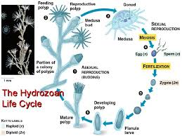
-Many exist in one or the other form primarily
-Corals are just polyps
-Jellies are just medusas
-Have stinging cells
-Cnidoblasts
-Contain nematocyst
-Box Jellies: One of the deadliest animals in the world
-Active hunter: stalks prey
-24 fully functioning eyes
-Carnivores
-Up to 10ft long 10in across
-Group of jellies are smacks or fluther
-Sea turtles eat Box Jellies
-Turritopsis dohrinii: “The Immortal Jellyfish”
-Used to be found only in the Caribbean but now found all over the world because it is transported by ballast water
-All of them are the same genetic clones
-Does backwards life cycle
-Injured or diseased, settles onto ocean floor
-Cellular transdifferentiation
-Somatic cells retain ability to change from one form to another.
-Sea Urchins can also do this
-Why do we care?
-Could we do this?
-Could we use this to make organs?

