Lecture 8:
Sediment:
-What are Marine Sediments?
-Eroded rock particles and fragments
-Transported to ocean
-Deposit by settling through water column
-Oceanographers decipher earth history through studying sediment
- Basically the soil of the ocean
-Holds information about primary productivity
-Weathering
-Breakdown of rocks and minerals through interaction with the planets atmosphere
-Physical Weathering
-Weathering through direct contact
-Ice, Heat, Water, Animals, Pressure, Plants
-As you go from few large particles to many small particles the surface area increases
-Chemical Weathering
-Changes the rocks chemical state
-Soil Ph, Temperature, Precipitation, Sediment Ph
-As plants respire it produces Carbonic acid which erodes and weathers the rock and soil around it
-Increases in temperatureincrease respiration increase chemical weathering
-Congruent Weathering Results in only dissolved ions
-Limestone weathering
-Increase in CO₂ increase in chemical weathering
-Incongruent Weathering Results in newly made clay materials and dissolved ions
-Rock+water+CO₂ Ions + Clay
-Grain size
-300mm-2mm= Gravel
-2mm-1/8mm= Sand
-1/16 mm- 1/300 mm= Silt
-Larger Particles found in high energy environments while Small Particles are found in low energy environments
-Deep sea is low energy and has small particles (silt and clay)
-Beaches are high energy and have large particles (sand)
-Marine sediment classification
-Where they come from
-Terrigenous or Lithogenous (from the land)
-Mostly at continental margins
-Coarser sediment at shore
-Eroded rock fragments from land
-Reflect the composition of rock
-Agents of transportation
-Water
-Watersheds deposit sediment into the ocean
-Wind (aolian)
-Dust clouds get picked up and moved into the ocean
-Ice
-Picks things up on land and melts and releases it into the ocean
-Gravity (turbidity currents)
-“Underwater landslides” large quantities of materials sliding off of the continental shelf into deep ocean
-Biogenous (from organisms)
-Hard remains of once living organisms
-Shells, bones, teeth
-Microscopic or macroscopic
-“Biogenous ooze”: 30% or more sediment is Biogenous
-Calcium Carbonate (calcite)
-Coccolithophres (algae)
-Calcium Carbonate Ooze
-Silica
-Diatoms (algae)
-Photosynthetic
-Radiolarians (protozoans)
- Siliceous ooze
Lecture 9 (continued from lecture 8):
-Contributing factors:
-Productivity: Number of organisms in surface water above ocean floor
-Hot spot on the surface
-Destruction: skeletal remains dissolve in seawater at depth
-Dilution: deposition of other sediments decreases percentages of biogenous sediments.
-Carbonate Deposits
-Stomatilites
-Fine layer of carbonate
-Warm shallow areas, high salinity
-Lived billions of years ago
-CCD: Calcite Compensation Depth
-Calcite dissolves readily after a point but to cold water and pressure
-Sediment Accumulation and Sea Floor Spreading
-Mid-Ocean ridges are above the CCD so calcite can build up and then Siliceous Ooze or Abyssal Clay covers it and protects in.
-Hydrogenous (from the environment)
-Chemical reactions occurring in the ocean
-Hydrothermal vents produce mineral precipitate
-Manganese nodules
-Phosphates
-Carbonates
-Cosmogenous
-Space Dust!!
-Very small amounts of sediment
-Volcanogenous
-Comes from volcanic ash that lands in watersheds or the ocean after an eruption
-Layering of different kinds of sediment tell a story about the history of that area of sediment. Well preserved
-Sediments are important for petroleum
-Petroleum often comes from diatoms under pressure for a long long time.
-Gas Hydrates: resemble ice but burn when lit

Lecture 10:
-Atmosphere:
-78.1% Nitrogen gas
-20.9% Oxygen
-Greenhouse Gases
-CO₂ is a Greenhouse gas
-Increases every year
-They are important to keeping the earth warm by trapping solar radiation but too much is a bad thing
-Seasons
-The tilt of the earth causes seasons because during orbit and rotation the distance a specific part of the planet moves closer and farther away from the sun.
-Uneven solar heating effects wind patterns and atmospheric reflection
-Albedo, White surfaces reflect solar radiation really well and cools areas. Black surfaces absorb solar radiation and heats an area.
-Positive feedback loop of arctic sea ice melting losing albedo and warming water and melting sea ice
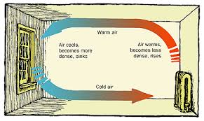
-Convection Cells
-Water does the same as air.
-Hot air holds more water vapor (low pressure system). Cold air releases water vapor (high pressure system).
-Coriolis Effect
-Attempts to understand how things that are not connected to the surface of the earth move in a rotating planet.
-Causes moving objects to follow curved paths
-To the right on the Northern Hemisphere, to the left on the southern hemisphere
-Changes at different latitudes
-Convection Cells:
-Hadley Cells: 0-30˚
-Ferrel Cells: 30-60˚
-Polar Cells: 60-90˚
Lecture 11:
-Wind blows from high to low pressure
-Weather is the day-to-day state of the atmosphere with short-term variation
-Climate is defines as the statistical weather information that describes the variation of weather at a given place usually within a 30-year span of time.
-Idealized three cell model
-Over simplification because it doesn’t account for many other factors…
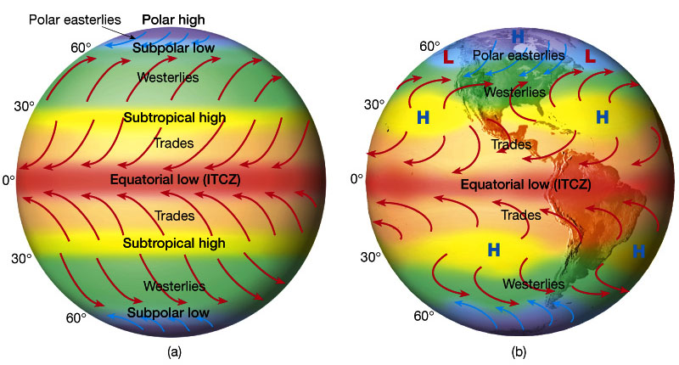
-Polar fronts at low pressure
-Wet climate with cloudy sky
-Horse latitudes at high pressure
-Dry climate with clear sky
-Inter tropical conversion zone (ITCZ) at equator
-Bands of clouds
-Shifts seasonally and moves other cells with it
-Flows: change depending on the hemisphere (for this class think northern hemisphere)
-Cyclonic flow
-Moves counterclockwise around at the northern hemisphere and clockwise at the southern hemisphere
-Anticyclonic flow
-Moves clockwise at the northern hemisphere and counterclockwise at the southern hemisphere
-Sea and Land Breeze
-Differential solar heating is due to different heat capacities of land and water
-Sea breeze: SeaLand
-Land breeze: LandSea
-Storms and air masses
-Storms: Disturbances with strong winds and precipitation
-Air Masses: Large volumes of air with distinct properties
-Land air masses are dry
-Marine air masses are wet
-Fronts: boundaries between air masses
-Warm Front: contact where warm air masses moves to colder area
-Cold Front: contact where cold air masses move to warm area
-Jet-stream: narrow, fast moving, easterly air flow
-Tropical Cyclones (Hurricanes)
-Large rotating masses of low pressure
-Strong winds with torrential rain
-Defined by maximum sustained wind speed
-Tropical Depression (less than 61km/hour)
-Tropical Storm (61-120 km/hour)
-Hurricane (more than 120 km/hour)
-Saffir-Simpson scale 1(slow)-5(fast)
-Has nothing to do with how much damage may occur, some of the most hazardous and deadly hurricanes have been categorized not as a 5 because their speed wasn’t as fast but a the flooding and storm surge were enough to cause lots of damage.
-Also called Typhoons (North Pacific) and Cy
clones (Indian Ocean)
-Requires: Warm ocean water, Warm wet air, the Coriolis effect
-Storm surge: Increase in shoreline sea level
-Really hard to find pattern of Hurricanes
-Hurricane Katrina:
-Cat 3
-Costliest and deadliest U.S. Hurricane
-Flooded New Orleans
-Mix of precipitation and Storm Surge
Lecture 12:
-Winds get named for the direction from which they come
-Currents get named for the direction in which they flow
-Ocean Currents
-Importance
-Transports 20% of latitudinal heat
-Equator to poles
-Transports nutrients and organisms
-Influences weather and climate
-Influences commerce
-Wind driven: Mainly moves water horizontally
-Active down to 1km
-Surface Currents
-10% of Ocean currents
-Develop because of the friction between wind and the surface of the water
-2% of wind energy is transferred to the ocean surface
-100 knot wind will create 2 knot current
-A Gyre is any large system of rotating ocean currents particularly those involved with large wind movements
-5 Subtropical Gyres
-North Atlantic
-South Atlantic
-Indian Ocean
-North Pacific
-South Pacific
-Warm currents go from warmer areas to colder areas (carry warmer water to colder water
-Cold currents go from colder areas to warmer areas (carry colder water to warmer water
-Western boundary currents
-Narrow, deep, fast moves warm water to the poles
-Gulf Stream and Kuroshio Current
-“Western” because they are on the western side of the gyre
-Eastern Boundry Currents
-Wide, shallow, slow moving cold water from the poles to the equator
-California Current, Canary Current
-Density or gravity driven moves water vertically
-Mixes water masses
-Because of the difference in density of hot vs. cold water
-How can we measure currents
-Satellites
-Buoys
-Rubber ducky’s
-Upwelling!!!!
-Brings nutrient rich water up to the surface from the bottom of the ocean
-Major regions
-California, Peru, Canary, Benguela, Somalia, Equatorial
-Ekman Spiral
-Describes how wind affects water, the speed and direction of flow of surface waters and various depths
-Coriolis effect causes things to shift slightly to the right
-Each water layer affects the layer under it
-Net movement is 90˚ from the wind
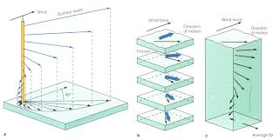
-This is the process that causes upwelling and downwelling
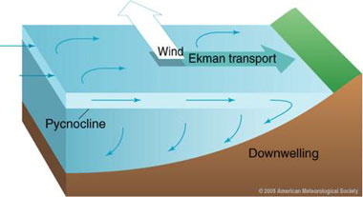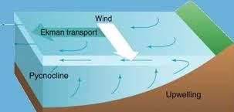
-Eddy
-A circular movement of water formed along the edge of a permanent current
-In an average year 10-15 rings are formed
-Warm Core Ring
-Rotates Clockwise
-Found on the landward side of the currents
-Cold Core rings
-Rotate Counter Clockwise
-Form on the ocean side of the currents
-Curtis Ebbesmyer
-A shipment of Rubber Duckies was shipwrecked off the coast of china and released the Duckies
-Currents moved them and deposited them as it went
-Scientists tracked them and within 15 years they were found all around the globe

