Ocean Currents:
- Wind currents (surface currents):
  - 10% of currents.
  - Only down to 1km.
- Density/Gravity Currents:
  - Other 90% of currents.
  - Deep water.
Deep Water circulation:
- Also called:
  - Thermohaline circulation.
  - Abyssal circulation.
  - Meridional overturning circulation.
  - Global conveyor belt.
- It is driven by density (density differences).
  - Density is a function of Temperature (“thermo”) and Salinity (“haline”).
Circulation of the Deep Ocean (the other 90% of the ocean):
- Salinity is the driving mechanism for circulation in the deep ocean.
- Thermohaline circulation: Driven by temperature and salinity.
  - The deeper you go the colder it gets.
    - The Thermocline: Till a certain depth the “surface water” is warm. At ‘X’ depth, the water suddenly gets cold.
  - The deeper you go, the higher the salinity.
    - Precipitation at the surface.
    - Salty brine.
  - The deeper you go, the more dense the water.
    - Colder, more briny water is more dense than warmer, less briny water.
      - The changes are VERY SMALL.
        - This little change makes a BIG DIFFERENCE.
    - Temperature is MORE important than salinity for driving density.
Temperature Variation with depth:
- Sun only heats the upper 100 meters.
- Deep water is cold.
- Density & T = mirror image.
- Temperature has a greater effect on density.
Sources of Deep Water:
- Low Latitude: strong thermocline → stratified.
  - There is more of a curve in the drop of temperature.
  - There will be stratified layers of different temperatures.
    - Warm Water acts like a lid. Prevents the formation of deep water.
- High Latitude: vertically well mixed.
  - Always cold (think the poles).
  - There is not much mixing → all the water layers are similar temperatures.
Driving Force:
- Wind cools the surface water (temperature drops), evaporates water vapor (salinity increases).
  - Decrease temperature, increase salinity.
Importance of Deep Water Stratification:
- Vertical stratification → important in dynamics and biology.
  - Important for life forms.
- Heat transport influences Earth’s heat budget and climate.
- It provides dissolved oxygen to the deep ocean.
  - Can be left depleted from decomposing organisms (bacteria).
- Deep ocean stores anthropogenic CO₂ (it takes 1000’s of years for one mixing).
  - Reason why there hasn’t been “crazy” climate change due to increased CO₂ levels.
- The Deep Ocean Circulation is how sea water is recycled in the ocean → like plate tectonic rock recycling.
  - Movement of nutrients.
Water Masses:
- Parcels of water exhibiting somewhat narrow ranges of Temperature and Salinity.
  - Water gets “chunked”.
The Conveyor Belt:
- Starts at NADW (North Atlantic Deep Water).
  - Sinks down as it goes.
- The polar water is STILL colder, so it remains on the very bottom.
  - It is where the warm water sinks down that deep water formation occurs.
- When water sinks down, it PHYSICALLY pulls the water behind it along.
  - “Like a conveyor belt”.
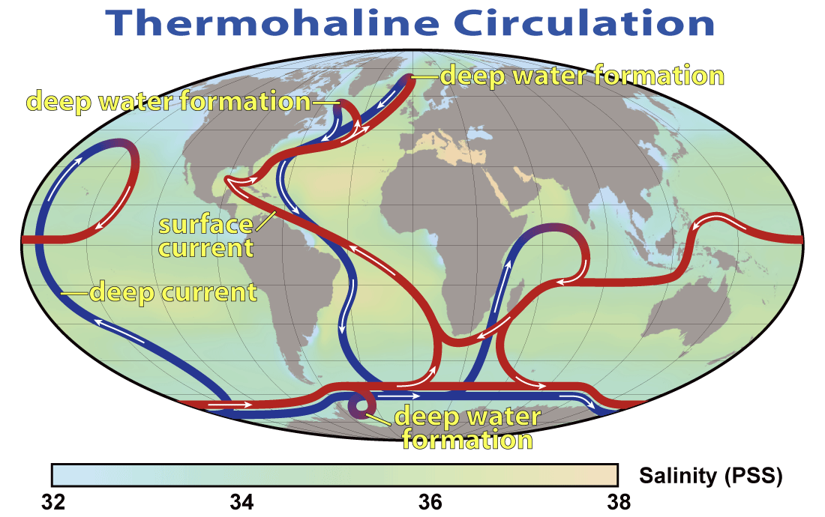
- There is no deep water formation in the North Pacific.
  - The lower salinity!
    - In the Atlantic there is a bigger variation of salinity levels throughout the ocean.
    - Due to the “land bridge” area between Alaska and Russia, the water is kept “fresh”.
      - This never allows the water to get salty enough to sink and created deep water.
The World Came Together~
- The Argo floats.
  - Move throughout the ocean, free to change depths.
  - When they come to the surface they “beam off” the information they’ve gathered in their most recent submerged adventure.
Examples of Tracers:
- Tritium (H-3): half life of 12 years.
- Radiocarbon (C14): half life of ~5700 years (especially from nuclear tests).
- Oxygen: consumed by organisms in the deep water.
- Nutrients: produced by organisms in the deep water.
- CFCs: Chlorofluorocarbons-Freons and SF₆ man-made, recently injected into atmosphere and thus into the ocean.
Thermohaline Circulation and Climate Change:
- Haline forcing is affected by excess precipitation, runoff, or ice melt.
- Slowdown or shutdown of the deep water circulation system.
  - Change salinity!
    - Ice melt → Greenland.
      - Fresh water would sit on top of the salty water, like a lid.
        - This would “stop” the deep water formation (driven by salinity).
- If the conveyor belt slowed down and or stopped, the world would be a much colder place.
  - About 30 years after the “stop”, the world would be changed.
  - The stop would not happen “overnight”.
- There have been changes in the deep circulation currents in the past.
  - 12,700 years ago after the most recent ice age the Conveyor belt was disrupted.
    - Temperature in the North Atlantic dropped by about 5ºC over the decade.
      - Disrupted by the melting of Ice that sat over Canada and flowed out into the North Atlantic → where two sits of deep water formation exist.
  - The cold period (Younger Dryas) lasted 1,300 years. It is named after an Arctic Wildflower.

“You can’t stop the waves, but you can learn to surf.” –Jon Kabat-Zinn.

Waves are moving Energy:
- Most (ocean) waves are wind driven.
  - Moving energy along ocean/air interface.
    - Wind is the main disturbing force.
    - Boundary between and within fluids with different densities.
- Air/water → ocean waves.
  - Think breaking waves on a beach.
  - Affects the surface of the water.
- Air/air → atmospheric waves.
  - In the atmosphere.
  - Seen in clouds.
    - Ripples.
- Water/water → internal waves.
  - Waves within different layers of water which are separated by densities.
- Splash waves:
  - Coastal landslides, calving icebergs.
  - Created by a mass being tossed into the water, displacing water.
- Seismic sea waves or tsunamis:
  - Created by seafloor movement.
    - Earthquake.
    - Underwater landslides.
  - The energy of this waves affects the entire water column.
- A Wake:
  - Created by ships.
- Tides:
  - Gravitational attraction among the Moon, Sun, and Earth.
  - Huge planetary sized waves.
Wave Anatomy:
- The Still Water Level:
  - If there was not a wave or any wind, the surface would be flat and glassy.
- The Wave:
  - Created when energy is applied and disturbs the water.
- Crest:
  - The top (peak) of the wave.
- The Trough:
  - The bottom (valley) of the wave.
- Wave Height (H):
  - Measured from the crest down to the trough.
- Wave Length (L or ‘landa’):
  - The length of the wave, measured from one crest to the next crest.
- Wave Period = T:
  - The time it takes for a full wave–or wavelength to pass a fixed position.
    - From one crest to the next crest.
  - For win generated waves, the period ranges from 6-16 seconds.
- Wave Frequency = f
  - f = 1/T
  - It is the number of waves passing a fixed location per unit of time.
  - It is the inverse of wave period.
  - Low frequency → a tide.
    - Long time to pass.
  - High frequency → constant crashing waves.
    - Short time to pass.
Water DOES NOT move in a Wave:
- Only the waveform moves in a wave.
- The net movement in the form is not water, but the energy that is moving through the substance.
Wave Motion:
- Waves transmit energy.
- Cyclic movement of particle in the ocean.
  - Particles may move:
    - Up and down.
    - Back and forth.
    - Around and around.
- Particles in waves move in an orbital pattern.
Body Waves: Include Longitudinal Waves and Transverse Waves.
Longitudinal Waves (push-pull waves):
- Think slinky.
- Particles move back and forth in direction of energy transmission.
- Energy transmitted by compression and decompression.
- Energy transmitted through solid, liquid, and gas.
Transverse Waves (side-to-side waves):
- Think cross fit training with ropes.
- Particles move at right angles to direction of energy transmission.
- Energy transmitted by vibration.
- Generally transmits energy through solids.
Surface Waves: Include Orbital Waves. They include characteristics present in the two forms of body waves.
Orbital Waves (in the ocean):
- Circular orbital movement:
  - Particles more in orbital path.
  - Energy transmitted along interface between two fluids or different density.
  - Circular orbits of an object floating at the surface have diameter equal to the wave height.

Wave Base:
- Equal to one ½ of the wavelength (at SWL) or L/2.
- As you move down through the water column (away from the surface), the size (the diameter) of the orbits decrease.
  - Makes sense for wind waves:
    - The energy source is the wind, at the surface.
    - The further you go from the energy source the less and less energy there is.
- The wave base is where there is not enough energy at all to keep making waves → it is still.
  - Out of the area in which the energy is.
- Wave base helps determine the different types of waves present in the ocean.
  - Deep Water.
  - Shallow Water.
  - Transitional.
Deep Water Waves:
- The water depth is greater than the wave base. (>½ L).
- Water is deep enough that the wave base is reached with no interaction with the bottom of the ocean.
  - Think open water, middle of the ocean.
- The orbitals are nice and circular shaped.
Shallow Water Waves (long waves):
- Water depth is less than the wave base (< 1/20 L).
- The water is shallow enough that the wave base interacts with the bottom.
  - Think coast, surfing.
    - If you get pinned under the waves, and held against the bottom.
- The orbitals are more oval shaped.
  - This is due to the interaction of the bottom.
Transitional Waves:
- Characteristics of both deep and shallow waves. Depth is greater than 1/20 wavelength and less than ½ wavelength.
  - It is a combination of both Deep Water Waves and Shallow Water Waters.
- The orbitals would not be quite as circular as Deep Water Waves, but not as ovaled as Shallow Water Waves.
- Think mid-water depth.
  - A wave was deep water, then it could be transitional, then a shallow water wave → as the wave reaches a beach.
Wave Speed:
- S = wavelength (L) / period (T).
- Wave Speed is more properly known as Celerity.
  - Used only in relation to waves where no mass is in motion, just the waveform.
    - No mass is being moved, only energy.
    - Speed is a movement of mass.
When Waves Meet:
- Two waves with the same wavelength:
  - In phase (they have identically timed crests and troughs): constructive interference:
    - The waves will build and make bigger waves.
  - Out of phase (one’s trough occurs at the other’s crest): Destructive interference:
    - The waves will reduce and make smaller waves.
      - “Flat”.
  - Mixed interference: Two waves of different occurring periods: Mixed Interference.
    - The waves will combine and make a series of many different waves.
      - Big, small, big, medium.
      - A giant mess.
    - Generally waves out in the ocean, no real pattern or direction.
How to build a big wave:
- Wind Speed.
- Duration: how long the wind blows in one direction.
- Fetch: distance the wind blows in one direction.
  - The open space that will not disrupt the wind.
Wave Development:
- Capillary Waves:
  - The little ripple waves on the water.
- Gravity Waves:
  - Built up from capillary waves.
- Wave Break:
  - Built up from gravity waves.
  - The 1/7th rule.
    - Wave Height H / wavelength L < 1/7th.
    - If the wave fails this 1/7th rule, it will break over on itself (whitecaps).
    - The wave is 7 m long, it can only be 1 m high. Otherwise, it would break.
  - Swells: Uniform, symmetrical waves.
- The largest waves occur around Antarctica.
  - The biggest fetch.
  - High wind speeds.
Drake’s Passage:
- Literally the worst water on earth.
  - Hell.
  - Except when Wally went (there was a freaking rainbow).
- It was the passing that used to have to be taken on trade routes to get to the west coast of the Americas.

Wave Steepness:
- Wave height (H) / wave length (L).
  - If the wave steepness exceeds 1/7 the wave will break.
- It is important to know wave size with:
  - Transportation / Shipbuilding.
    - Need to build boats that could withstand rough seas.
  - Coastal living.
    - Size of the waves that will be breaking on the beach (you) live near.
- A 7 meter long wave could only be 1 meter high without breaking.
Wave Scaling:
- The Beaufort Wine Scale and the State of the Sea.
  - 0 → Glass, no waves or wind.
  - 11 (56-63 knots) → Maximum wind and waves.
  - 12 (63+ knots) → The ultimate extreme.
How Big can a wine generated wave be?
- According to the US Navy 60 ft (18.3) is the max.
  - The USS Ramapo → Was in a Typhoon in the Pacific Ocean.
    - Was believed to be in seas with 112 ft waves (34 meter).
Categories of Freak (Rogue) Waves:
- “Walls of Water” traveling up to 10 km (6.2 mi) through the ocean.
- “Three Sisters” group of 3 [rogue] waves.
- Single, giant storm waves, building up to fourfold the storm’s waves height and collapsing after a few seconds.
  - A good example of a constructed wave.
The New Year’s Wave:
- The Draupner wave. A single giant wave measured on New Year’s Day 1995, finally confirmed the existence of freak waves, which had previously been considered near myth.
In the ocean ocean: 1 in 23 is 2X as high as the seascape. 1 in 1,1175 will be 3X as big. 1 in 300,000 will be 4X as high and TRULY BIG is 1 in several billion.
- A handful of ships go missing yearly.
  - Ship insurance companies are cautious about this, but it is a true mystery about what happens to these ships.
Wave Energy:
- Fully Developed Sea:
  - Maximum wave height, wavelength for particular fetch, speed, and duration of winds at equilibrium conditions → they lose energy through braking as fast as they gain energy from the wind.
- Swell:
  - Uniform, symmetrical waves that travel outward from storm surge.
Swells:
- Ground Swells:
  - Deep ocean swells, one that might be generated by a distant storm or earthquake.
- Wind Swell:
  - More local origins, more common.
As Waves Approach the Shore:
- Wave speed decreases.
  - Friction from the sea floor slows it down.
- Wavelength decreases.
  - Waves get bunched up together, like a rug.
- Wave height increases.
  - Due to bunching, the wave’s get taller.
- Wave steepness increase.
- Waves break.
Beakers in Surf Zone:
- Top of wave topple over base because of decrease in wave speed due to friction with sea floor.
- Wave form not sustained.
- The substance of the seafloor and shape is important.
Spilling Breaker:
- Water slides down front slope of wave.
- Gently sloping sea floor.
- Wave energy is expanded over a long distance.
Plunging breaker:
- Curling crest.
- Moderately steep floor.
- Wave energy expanding over a shorter distance.
- Bet for surfers.
Surging Breaker:
- Beaker on shore.
- Steepest sea floor.
- Energy is spread over the shortest distance.
- Best for body surfing.
Surfers:
- Shawn Dollar:
  - Paddling into a 61 foot wave off San Diego.
  - Paddle in record.
- Aaron Gold:
  - Paddling it a beach called Jaws to surf an over 50 foot wave.
- Maya Gaberia:
  - Paddling in at Dungeons Beach to surf at 45 foot wave.
- Garrett McNamara:
  - Record biggest wave surfer.
Better Surfing, East or West?
- West:
  - Fetch and duration are bigger.
  - Continental Shelf steepness.
  - Wind blows into the shore.
Tsunami or Seismic Sea Wave:
- Caused by sudden changes in sea floor.
  - Earthquake, volcano, landslides.
- Long wavelengths (> 200 km or 125 mi).
- The wave interacts with the entire water column → TONS of energy.
- Shallow-water wave.
- Speed proportional to water depth so very fast in open ocean.
  - In the middle of the ocean a tsunami could pass under you and you may have no idea.
- Sea level can rise up to 40 meter (131 ft) when the tsunami reaches the shore.
  - All the energy in the tsunami needs to go somewhere, so it goes up.
- Most occur in the Pacific Ocean (more tectonic activity).
- Very damaging to coastal areas.
- Great loss of life.
Typical wavelength for a tsunami:
- Speed:
  - Square root of gravity x depth.
“A rising tide lifts boats” –Proverb quotes

What’s a Tide?
- Tides are the rhythmic rise and fall of the sea level.
- Tides are very long and regular shallow water waves.
- Tides are caused by gravitational attraction between the Sun, the Moon, and the Earth.
- Different tidal patterns exist!
Sir Isaac Newton:
- The Gravity Man~
- Newton’s law of universal gravitation:
  - Every object in the universe is attracted to every other object.
Tide Generated Forces:
- Barycenter between the Moon and Earth.
  - Both the Earth and Moon are rotating around the sun.
- Barycenter: it is the inbetween space between the Earth and moon.
  - The barycenter (or barycentre; from the Greek βαρύ-ς heavy + κέντρ-ον centre) is the center of mass of two or more bodies that are orbiting each other, or the point around which they both orbit.
Gm₁m₂
F_{g} = ––––––
R²
- Fg = gravitational force.
- M = mass of body.
- R = distance between the two bodies.
- When mass increase, the gravitational pull increases.
- If distance increase, the gravitational pull decreses.
  - Due to this, the moon plays a more important role in tidal attraction.
    - It is closer to the Earth than the Sun.
    - In this case, distance is more important than mass in terms of gravitational force on the oceans.
Gravitational Forces:
- Every particle attracts every other particle.
- Gravitational force proportional to product of masses.
- Inversely proportional to square of separation.
  - Zenith = greatest force.
  - Nadir = least force.
    - These are both opposite terms to each other.
Centripetal Force:
- There is a center-seeking force that tethers the Earth and Moon together.
  - Pulls the Earth and Moon together.
Tide-producing Forces:
- Resulting forces = differences between centripetal and gravitational forces.
  - Multiple forces are working together or against each other to make resulting forces.
- Tide-Generating forces are horizontal components.
Tidal Bulges (lunar):
- Small horizontal forces pushes seawater into two bulges.
- They exist on opposite sides of the Earth.
  - One bulge faces the Earth.
  - The other bulge is on the opposite side of the Earth.
- Think about the water on the Earth beings pulled → making the “round” Earth move oval-like.
- Two tidal bulges:
  - In a perfect world this would mean : Two high, two low tides.
    - 12 hours apart.
- High Tide: Flood Tide:
  - Water is being pushed up onto the shore.
- Low Tide: Ebb Tide:
  - Water is being pulled away from the shore.
The Lunar Day:
- A lunar day is 24 hours and 50 minutes. This is because the Earth and Moon rotate at slightly different speed → they do not rotate at the same speed together.
  - This makes high tides 12 hours and 25 minutes apart.
Earth-Moon-Sun positions and spring and neap tides:
- Neap: Unusually Mild Tides.
  - Happen at Quarter moons.
    - The Moon and Sun are not lined up → SHRIMPY GRAVITY POWERS.
- Spring: Very Big Tides
  - Happen at New of Full Moons.
    - The Moon and Sun and lined up → MAXIMUM GRAVITY POWERS.
- Spring Tide with Hurricane:
  - The biggest Spring Tides:
    - Combination with already bigger Spring Tides + Hurricane Tidal Surge:
      - IT OVERS 9,000 (tidal power).
Monthly Tidal Cycle:
- Waxing Crescent:
- Waxing gibbous
- Waning gibbous:
- Waning Crescent:
Other Complicating factors:
Declination:
- Due to the tilted nature of the Earth and the relation of the SUn and Moon leads to an irregular tidal bulge.
Elliptical Orbits:
- The Orbit of the Earth and the Orbit of the Moon are not circles:
  - They are elliptical:
    - Perigee: Moon closest to the Earth.
      - Considering Northern Hemisphere:
      - January Perihelion.
        - Winter storms → Greater Tides.
    - Apogee: Moon furthest from the Earth.
      - Considering Northern Hemisphere:
      - July Aphelion.
        - Summer Storms → Smaller Tides.
    - The cycle between these two positions is about 27.5 days.
  - Proxigean tides: spring tide + perigee.
    - Exceptionally high tidal range.
Real Tides:
- Earth not covered completely by ocean.
  - There are the continents.
- Continents and friction with seafloor modify tidal bulges.
  - Consider different continental shelf shapes and steepness.
- Tides are shallow water waves with speed determined by depth of water.
- Tidal bulges cannot form (too slow to keep up with the earth’s rotation).
- Instead large circulation cells in the ocean basins dictate how tides form in different oceans.
Tidal Cells in the World’s Oceans:
- Crests and troughs of tides rotate around the amphidromic point.
  - No tidal range at these points.
- Cotidal lines: connect simultaneous high tide points.
  - The maximum tidal heights exist in the middle of the cotidal line.
- Tide waves rotates once in 12 hours.
- Tides move at a speed of 1,600 km (1,000) per hour.
  - Keep in mind this is the speed of the energy moving (not the physical water)!
Tidal Patterns:
- Diurnal:
  - One high, one low tide per day.
  - Tidal period is 24 hours and 50 minutes.
    - Not that common on the world’s coasts.
- Semidiurnal:
  - Two high, two low tides per day.
  - Tidal range is about the same.
  - Tidal period is 12 hours and 25 minutes.
    - Most common on world coastlines.
- Mixed:
  - Two high, two low tides a day.
  - Tidal range is different!
  - Tidal period is commonly 12 hours and 25 minutes (sometimes diurnal tidal periods).
    - Almost as common as the semidiurnal tidal pattern.

Ecology:
- It is the study of animals at home.
- The word comes from the greek word ‘oikos’ which means home.
- Ecology is the study of the inter-relationships between the physical and biological aspects of the environment.
  - The Biotic (life) and Abiotic (non-living) characteristics.
- It is the study of how organisms adapt to their changing environment.
What is the definition of Life?
- 7 qualities that define life:
  - Creates waste.
  - Reproduces (sexual or asexually or both).
  - Moves (reacts to stimuli).
  - Have genetic material (DNA).
  - Consumes (eats or takes in sun’s energy) able to capture, store and transmit energy.
  - Grows (change over time).
  - Can adapt to their environments.
Oceanic Realms of Life:
- Pelagic: the water column.
  - Talking about the open ocean generally.
- Benthic: the bottom.
  - Not always the deep → it refers to the seafloor.
    - Can be shallow, can be deep.
Ocean Zones by depth:
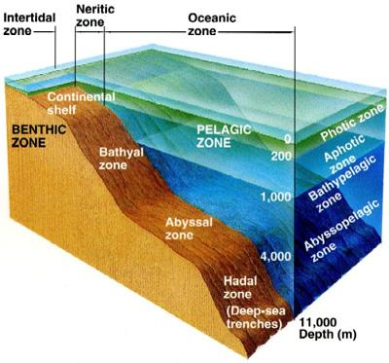
- Epipelagic: from surface to 200 m.
  - Small.
- Mesopelagic: from 200-1000 m.
  - Not as small.
- Bathypelagic: from 1000-2000 m.
  - Medium.
- Abyssopelagic: from 2000-6000 m (to the deepest parts of the ocean).
  - Large chunk.
- Hadal: Greater than 6000 m (the deepest deeps).
  - Exists in the deepest ocean trenches.
Ocean Zones by Light:
- Photic:
  - The surface to around 100ish m.
    - Where 99.1% of primary productivity occurs.
    - Sunlight allows for photosynthesis.
- Dysphotic:
  - 100-500ish m is the Twilight Zone.
    - Little light.
- Aphotic:
  - 500ish m to the bottom.
    - Absolutely no light.
How many species live in the ocean:
- The estimaton is more than 250,000.
- It is believed there is another 750,000 to 1 million more species.
Linnaeus:
- In 1735 Linnaeus developed the taxonomic classification of zoology.
- D K P C O F G S.
  - Did King Phillip Come Over For Good Spaghetti?
  - Names consist of genius and a trivial name.
The Major Kingdoms:
- Monera:
  - Includes things like bacteria, cyanobacteria and archaebacteria.
- Protista or Protoctista:
  - Single or multi celled organisms with a nucleus. Includes single celled algae or animals.
- Fungi:
  - Abundant in the intertidal zone and are important in decomposition, 100,000 species or molds/fungi–but overall very few discovered in the ocean.
- Plantae:
  - Plants. Free-floating or attached to the seafloor.
- Animalia:
  - All multicellular animals (sponges to whales).
The Two (Old) Domains:
- Prokaryote:
  - No cell organelles.
  - No nucleus.
  - Usually DNA is a single molecule.
    - Would have included the TWO MODERN domains bacteria and archaea.
- Eukaryotes:
  - Cells have a nucleus.
  - Have membrane bound organelles.
  - Usually multicellular but can be single celled.
Woese:
“I hadn’t been trained as a microbiologists, so I didn’t have this bias [about impossibility of bacterial classification]”.
- Came up with the idea with a new super kingdom known as Archaebacteria.
  - People called him crazy and told him to forget about it!
- Most microbiological work NOW is focused on the ideas of Woese.
The Added Third Domain:
- Life could not be classified by the two-domain system of bacteria and eukaryota.
  - Archaea needed to be included.
- Archaea:
  - The extremophilic.
    - Found in extreme environments → like Yellowstone (think boiling mud pits), and Hydrothermal Vents.
    - They have been found everywhere though.
  - They have unusual cellular membranes and a flagellar structure.
  - Their cellular coating is unique.
    - Can be square shaped.
  - They have a different type of RNA polymerase (Margulis and Schwartz).
  - They are incapable of living in air.
    - DO NOT LIKE OXYGEN.
  - Believed to be one of the earliest forms of life on earth.
- Bacteria:
  - All are prokaryotes.
    - Lack a nucleus or membrane bound organelles.
  - Tend to be very small.
Marine Genomics:
- Can take samples of whale skin and study all of the microbes on the sample
  - Can tell how they breathe, how they reproduce, and other things.
Recap:
- Three Domains:
  - Bacteria
  - Archaea.
  - Eukaryota.
- Five Kingdoms:
  - Animalia.
  - Plantae.
  - Fungi.
  - Protesta.
  - Monera.
- King Phillip Came Over For Good Spaghetti.
  - Kingdom.
  - Phylum.
  - Class.
  - Order.
  - Family.
  - Genus.
  - Species.
    - Starts broad, becomes more specific.
Today:

Plankton (floaters):
- Are unable to control where they swim.
  - Too small, no muscles, can not actively swim.
Nekton (swimmers):
- Have muscles and can actively swim.
Benthos (bottom dwellers):
- The things which live on the bottom or in sediments.
Pelagic:
- Plankton:
  - Idea of aimless wanderer.
  - Do not have sustained movement and but can direct horizontal movement.
    - Production of oils in algae → keep contained to float up, release to float down.
    - They may have moving parts but they still can not sustain long term swimming.
  - Most jellies included. Generally can’t swim against the currents.
- Nekton:
  - Are active swimmers.
    - They have muscles.
  - Consider fish.
Types of Plankton:
- Autotrophic: phytoplankton (also include those which do chemiosmosis).
  - Photosynthesis.
- Heterotrophic: zooplankton.
  - Consumers.
- Phytoplankton:
  - Autotrophic: They photosynthesize and make their own food.
- Zooplankton:
  - Heterotrophic: Need to consume. Can’t photosynthesize.
- Bacterioplankton:
  - They’re very small.
  - They make up at least half the ocean’s photosynthetic biomass.
    - Probably the most abundant photosynthetic organism in the ocean.
- Virioplankton:
  - Smaller than bacterioplankton.
  - Not well understood, may limit abundance of other plankton through infection.
    - They are viruses.
      - Are they alive? The debate continues.
Life Cycle Classification:
- Holoplankton:
  - They live their whole life as plankton.
- Meroplankton:
  - Only a part of their life is spent as a plankton.
    - Generally juvenile or larval stage.
  - Example: The Crab.
    - Larvae are plankton, adults are benthic.
  - Example: The Squid:
    - Benthic eggs, planktonic larvae, nekton adults.
Classification by Size:
- Macroplankton:
  - Large floaters such as jellies or Sargassum.
- Picoplankton:
  - Very smell floaters such as bacterioplankton.
- F P N Mi Me Mac Mega
Benthos: The Bottom Dwellers:
- Epifauna: Organisms that live on the surface of the seafloor.
  - Example: Starfish. Urchin.
- Infauna: Organisms that live buried in the sediment.
  - Example: Clam. Worm.
- Nektobenthos: Organisms that can swim or crawl through the water above the seafloor:
  - Example: Crab.
- The benthos are most abundant in shallower water.
  - This is because many nutrients are dependent on the closeness to the surface.
    - Photosynthesis.
- Many also live in perpetual darkness, coldness, and stillness.
  - The creatures which live on the bottom of the deep ocean.
Ocean Primary Production:
What we see as a class:
- More primary production towards the poles.
  - Lots of river runoff into the poles.
    - Carrying nutrients.
- More production at the mouths of rivers.
  - Nutrient run off into the ocean via rivers.
- More production on the equator, but not above and below.
  - The gyres are places of low productivity.
  - Upwelling motion occurring at the equator.
Hot Spot(s) of activity:
- Eelgrass.
- Kelp.
- Mangroves.
Big Picture:
- Phytoplankton are the organisms which are “running the engine” of the earth in terms of photosynthesis.
  - 47% of global primary production comes from the ocean.
    - This huge amount of photosynthesis is done by phytoplankton which are only 0.2% of the planets biomass.
Grass of the Sea:
- Phytoplankton have the same role as grass → they are the base of the food web which supports all other life.

“Each day as the sun rises and retires the beautiful green bays like great Creatures breathe in and out. By day photosynthetic production of food and oxygen is Plentiful, but day and night there is also a furious feasting.” Odum and Hoskin, 1958.

Primary Production:
- Organic matter is synthesized from inorganic substances.
  - Photosynthesis: Producing organic matter from CO₂, water, and light.
6CO₂ + 6H₂O + Light → C₆H₁₂O₆ + 6O₂
Key Terms:
- Biomass: The static measure of how much is there.
  - Generally grams. (How many grams (is a cat)?).
- Primary Production: It is a dynamic measure of how much is produced per unit of time.
  - It is a rate. (How many grams per day?)
  - The area in which it takes place is also important.
    - Estuary or gyre?
The 3 Primary Controls (Limiters) of Productivity:
- Photosynthetic Light.
  - One of the more common limiting factors.
  - THE SUN.
    - Light for photosynthesis is available only in the top 100 or so meters (Euphotic zone) of the water column.
      - The deeper down you go, the less your rate of photosynthesis will be.
        - Too deep = death.
      - Only 1% of the energy from the surface will be at the 100 meter line.
        - “The 1% light level.”
  - The wavelength of light that can go the deepest is blue light.
    - Will hang around till 100 meters.
  - The wavelength of light that can go the least deep is red light.
    - Completely gone by 10 meters.
      - Many deep sea animals are red when light is shown on them.
        - Great camouflage down deep because there’s no red light to reveal them to advanced eyes.
  - Phytoplankton can be self shading.
    - Will prevent light from going deeper by making a sort of “lid”.
  - Sediment and other material can also block out sediment.
    - Water turbidity.
- Dissolved inorganic nutrients.
  - The other more common limiting factor.
  - The Major Nutrients:
    - Carbon: important, but it is abundant in water.
    - Nitrate (NO₃⁻),₋ Nitrite (NO₂⁻) and Ammonium (NH₄⁺)
      - DIN.
        - Dissolved Nitrogen (groups).
    - Phosphate (PO₄³⁻)
      - DIP.
        - Dissolved Phosphorus.
    - Silicate (SiO₄)
      - DIS.
        - Dissolved Silica.
106 CO₂ + 16 NO₃⁻ + PO₄³⁻ + 122H₂O +19H⁺ + Light → (CH₂O)₁₀₆(NH₃)₁₆(H₃PO₄) + 138O₂.
    - Known as the redfield ratio.
      - C : N : P = 106 : 16 : 1
    - Diatoms?
      - C : N : P : Si → 106 : 16 : 1 : 16
  - 1855: Liebig’s Law of the Minimum:
    - Figured out on land, Nitrogen was the most common limiting nutrient.
    - Turns out, nitrogen is also the most limiting nutrient in the ocean as well.
      - Once he found this out, he knew if you applied nitrogen to crops it could fix soil issues.
        - This led to the present issue of excess → Humans use EXTRA nitrogen on crops.
        - Leads to the run off of the extra nitrogen, and very little is actually taken up into plants/animals.
        - Leads to a whole bunch of bad, because it is left floating around in the ocean.
    - He’s the “Father of Fertilizer Industry”.
    - Phytoplankton growth is determined by the response of phytoplankton to the single factor that is most limiting.
      - Can include things like N, P, P, Fe, Si and other trace minerals.
        - The “weakest link.”
- The amount of grazing by zooplankton occurring:
  - How fast the consumers are eating the producers.
Where are sources of nutrients to the ocean?
- Decomposition:
  - Dead things will give nutrients back to the environment.
- Outgassing:
  - Could bring CO₂ in.
- From Land:
  - Rivers and Direct runoff.
- Continental Weathering:
  - The weathering of rocks/minerals.
    - Carried down by rivers or wind.
- Water Treatment Plants:
  - Direct discharge of waste into the ocean.
  - As shown by chlorophyll satellite scan:
    - NYC → Direct sewage discharge into Long Island Sound.
    - Chesapeake Bay → Mostly livestock waste discharge into the bay.
Respiration:
- Everything respires.
O₂ + Organic matter → CO₂ + NO₃ + PO₄ + H₂O
- Also called remineralization, regeneration, degradation.
  - The thing that is the “ying-to-the-yang” of photosynthesis.
    - Allows life to continue.
- Phytoplankton:
  - Could be eaten and turned into fecal pellets.
  - Could just die and be planktonic tests.
  - “Marine Snow.”
    - The constant sinking (snow) of fecal pellets and tests.
In Class Drawing thing:
- When will respiration be higher than photosynthesis?
  - Below 100 meters.
    - Photosynthesis can’t happen below this depth, only respiration could occur.
- Photosynthesis would be highest:
  - Above 100 meters.
- Respiration would be highest:
  - At 1,000 meters.
- Why does oxygen levels go back up after 1,000 meters?
  - The answer is marine snow.
    - It would have been eaten higher up, the deep you go the less “appealing” is the snow
    - Also it is cold.
      - Metabolism goes down with temperature.
        - Demand for oxygen is much less.
    - Deep water formation.
      - It’s cold.
      - There’s a higher gas concentration in cold water.
        - Oxygenated water at depth, came from far away lands and sank due to temperature.
        - Is now chilling down there.
        - Thermohaline circulation.
    - Not a ton of life down there.
      - Not much respiration is occurring → levels remain pretty high.
- Nitrogen?
  - Lowest levels are above the 100 meter line.
    - Nutrients being consumed by photosynthesizing things.
  - Highest level is at 1,000 meters.
    - Where there is no photosynthesis → not a huge demand for consumption by the photosynthesising things.
  - Decreases down with depth again (only a little), but remain pretty high as well with depth.
“So on a summer’s day waves collect, overbalance, and fall; collect and fall; and the whole world seems to be saying “this is all” more and more ponderously, until even the heart in the body which lies in the sun on the beach says too, That is all. Fear no more, says the heart. Fear no more, says the heart, committing its burden to some sea, which sighs collectively for all sorrows, and renews, begins, collects, lets fall.” –V. Woolf

Carbon:
- With the fall of marine snow, the carbon them carry in their bodies also drops down to the depths.
  - Helps regulate carbon distribution.
Vertical distribution of Nutrients:
- In all oceans:
  - Low nutrients in the top 100 meters.
    - Consumption by photosynthesis.
  - 100 meter peak.
    - They are refreshed by respiration.
Phytoplankton Bloom:
- A bloom is a massive explosion of growth.
  - So massive it colors the water.
- Why do we care?
  - Fear from possible Dead Zone.
  - Toxins related with the algae?
    - Fishing.
  - Blooms would attract other organisms that would feed off the bloom.
    - Would attract many forms of life (the food web) that would begin with the phytoplankton.
- Sverdrup’s Model of Critical Depth (Goldylocks):
  - Photosynthesis decrease exponentially with depth due to decrease in light availability.
    - Less light → less photosynthesis.
    - There is an exponential curve in the way light decreases with depth.
      - Lower at the surface. Peak occurs around 30% down in the euphotic zone.
        - The phytoplankton can be negatively impacted right at the surface by too much light.
          - “Sunburned.”
  - Respiration is unaffected by light and remains constant with depth.
    - Holds up till about 100 meters.
      - Would be graphed as a straight line down.
  - The Compensation Point:
    - The point where the rate of photosynthesis equals the rate of respiration.
      - RATE.
  - The Critical Depth:
    - Where the area under the entire curve under the photosynthesis is equal to the total area of respiration.
      - The amount of total organic matter made by photosynthesis equals the entire amount of organic matter consumed by respiration.
      - MASS.
    - Above this point: more organic matter is made than consumed.
      - ALLOWS for an algae bloom.
        - There’s an “excess” of organic matter.
    - Below this point: less organic matter made than what is desired to be consumed.
      - Would make an algae bloom impossible.
Low / High Latitudes:
- Low latitude: (think Caribbean):
  - There is a nice hot upper layer of water.
    - Less dense.
  - There would be a long thermocline level as it goes deeper.
- High latitude: (think Antarctica):
  - The water is very well mixed.
    - High winds (storms).
      - Would be an issue for phytoplankton because they could get forced down into too deep water and die.
        - Unable to do sustained swimming.
  - The thermocline line is straight down.
- Phytoplankton:
  - Need a balance:
    - Need the balance between light and depth.
Primary Production:
- Polar Ocean:
  - Nutrients are abundant due to vertical mixing.
  - Limited by sunlight: darkness for winter months.
    - Highest production peak in the spring.
      - When the sun is exposed!
    - Slow decrease over the summer.
      - Consumption.
  - Partial coverage by sea ice.
- Temperate Ocean:
  - High levels of nutrient in the Fall and Winter.
  - Low levels of nutrients in the Spring and Summer.
  - The sunlight is a belly curve which peaks in the middle of summer.
  - There is a huge phytoplankton bloom in early spring.
    - First exposure of sunlight, nutrients still high from winter.
    - The level of nutrients would remain low.
      - The production of phytoplankton is still HIGH, and nutrient consumption is rapid!
  - Zooplankton peak occurs after the phytoplankton.
  - There is a smaller fall peak of phytoplankton, and the levels of sunlight are reducing slowly.
  - There will also be a second (much smaller) zooplankton spike, following the fall phytoplankton bloom.
- Tropic Ocean:
  - There will be no BIG change.
    - Big summer bloom, smaller fall bloom.
    - Big single zooplankton bloom in the middle of the phytoplankton blooms.
“It was the best of times, it was the worst of times, it was the age of wisdom, it was the age of foolishness, it was the epoch for belief, it was the epoch of incredulity, it was the season of Light, it was the season of Darkness, it was the spring of hope, it was the winter of despair, we had everything before us, we had nothing before us, we were all going direct to Heaven, we were all going direct the other way.” –C. Dickens

Without Greenhouse Gases:
- The world would be -18ºC colder globally.
Mauna Loa Observatory:
- Graph taken since the 1950s to nearly today.
  - The CO₂ concentration in ppm has gone up A LOT.
    - In about 100 years, we went from about 200 ppm to just over 400 ppm.
- The industrial revolution (coal), was the beginning of this rise.
- Why are their peaks and troughs in the line?
  - Seasons!
    - “Breath of the Earth.”
      - The earth inhaling CO₂ → Photosynthesis.
      - The earth exhales CO₂ → Respiration.
- With increasing CO₂…
  - The overall global temperature would raise.
  - This “heating” would be an issues for our children/grandchildrens generation.
Phytoplankton:
- Have the ability to decrease the amount of CO₂ in the atmosphere.
  - Take CO₂ from the atmosphere and fix it into the deep ocean.
- There’s 50 times more inorganic carbon in the ocean than in the atmosphere.
  - The ocean is holding onto this inorganic CO₂.
The Solubility Pump:
- The physical movement of water (and CO₂) down into the ocean.
  - Deals with physics.
- Gas exchange allows CO₂ to enter the ocean.
  - Flux depends upon air-sea CO₂ difference.
    - Solubility increase in cold water!
      - Polar regions sinks, equatorial regions rise.
        - Major upwelling areas → sources of CO₂ release!
        - Polar regions “suck in” CO₂ which would sink down to the depths due to the cold water temperatures.
The Biological Pump:
- When CO₂ is fixed into phytoplankton, when they fall down into the ocean (dead or as fecal pellets), the CO₂ also falls down into the deep ocean.
  - COMPLEXITY.
- There is nothing to do with the physical vertical movement of water.
- This is all driven by biology.
  - Food webs (who eats who).
- Whale fall:
  - The dead whale’s body sinks down to the depth, taking with it a whole lot of fixed carbon (fixed in its body).
- Along with the downward fall of carbon, nutrients also fall down into the deep ocean.
  - Fall below the “active biologic level” in the ocean.
- If the biological pump was turned off the atmospheric CO₂ level would increase by about 200 ppm.
  - Goes from the present 400 ppm to 600 ppm.
    - This is bad. We don’t want this.
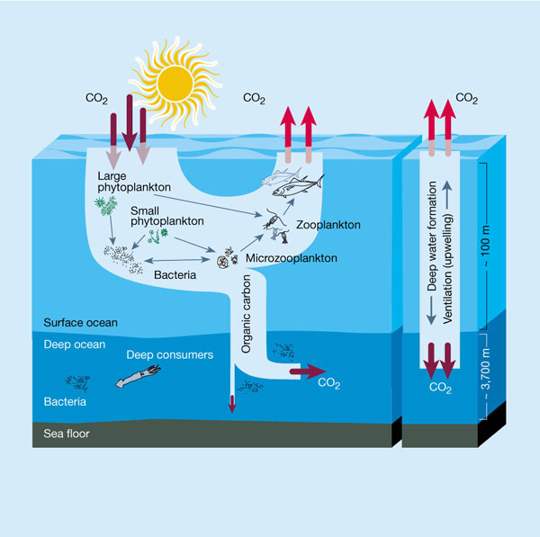
What controls the Biological Pumps Efficiency?
- Inverted Pyramid:
  - Carbon Uptake → by Primary Production.
    - Fixed into the Phytoplankton.
  - Carbon Flux @ 100 m → the smaller proportion of carbon that is exported through sinking particles.
    - Only about 5-15% (gone from the surface for decades).
  - Carbon Flux @ 1,000 m → even smaller!
    - Only about 1% (gone from the surface for centuries).
  - Carbon burial @ the bottom → very small percent!
    - Only about 0.1% (gone from the surface for a millennium).
What controls Phytoplankton Primary Production:
- Temperature:
  - Warmer water temperatures.
- Photosynthetic light (sun angle or mixing):
  - Summer months → more sun exposure.
- Major nutrients (C, N, P, and Silica):
  - Redfield Ratio:
    - 106 : 16 : 1 : 16 ratio!
- Grazing:
  - How much consumption is happen.
- Micronutrients (Iron):
  - Certain phytoplankton also require iron (like us)!
  - In experiments:
    - Colonies grown with iron would grow more than colonies without iron.
    - Conclusion: Iron acted like a fertilizer to some diatoms.
HNLC areas of High Nutrient Low Chlorophyll:
- Vast areas in the oceans have plenty of nutrients, and yet there is little chlorophyll (phytoplankton).
  - Why??
The Minor Nutrients:
- Iron (Fe), Zinc (Zn), and other metals.
  - Called “minor” because they are required in much smaller amounts than the other nutrients.
- Nitrogen → Consumed in the top 100 meters.
  - Zinc and Iron are also consumed in the top 100 meters.
- Sodium → A conservative element:
  - It will not change in regards to biological activity!
    - “Straight line” down through the water column.
“Give me a half a tanker of iron, and I will give you an ice age,” –John Martin.
- Add iron to limited areas of the ocean → stimulates phytoplankton and photosynthesis → would also be fixing CO₂ into their bodies → would die and sink down into the depths → carrying CO₂ down with them.
The Ultimate Test:
- Enriched a small area of the ocean by adding iron along with an inert and sensitive tracer.
  - These tests were performed in HNLC areas of the ocean
- Follow what happens through time by ship-board measurements and satellite collection.
- The results:
  - Phytoplankton grew rapidly in response to iron enrichments in all environments; diatoms grew the most rapidly.
  - However, little to no increase in carbon was observed.
    - Made things worse?
      - Made more phytoplankton → more food to be eaten.
        - Leads to higher levels of respiration, and more CO₂ release.
        - Would drop the pH of the ocean.
      - Also selective selection of a specific algal species.
        - Could mess up the food webs.
  - Most colonies grew rapidly until they had used up all the available iron.
- Experiments are still ongoing, but the results are very random.
H.A.B.S → Harmful Algal Blooms (In the know).
Biblical: Could the Nile have “turned red as bloom” as a result of a harmful algal bloom? Some algal blooms can be so intense (red) they look like blood.
HABS:
- Nuisance Bloom:
  - Not “harmful”.
    - Do not give off toxic gases or chemical compounds.
  - They will still die and the process of decomposition would reduce oxygen levels in the water.
- Abundance:
  - Phytoplankton can grow so much that they make a lid on the surface of the water.
    - This prevents sunlight from getting down into the water column.
      - Problem for sea grasses.
  - Oxygen depletion:
    - Due to decomposition, the oxygen levels will be reduced.
  - Mechanical irritation:
    - If consumed or “breathed” in, the rough shapes of some algae can actually cut up the organism’s (fish) insides.
**We are talking about Phytoplankton Today (NOT Bacteria)**
Dinoflagellates:
- Single celled.
- They have 2 flagella.
- They can be bioluminescent.
  - Tend to be green or blue colors.
    - Would result in blue or green colorations.
- Harmful algae blooms.
  - They can give off toxins.
  - Generally the normal species in regards to harmful algal blooms.
- 6-8 million per liter.
Red Tide:
- Give off toxins.
- Most common result is fish kills.
Different Degrees of Bad:
- Neurotoxic Shellfish Poisoning (NSP).
  - Brevetoxin → Can be in oysters, makes humans very sick.
    - It is a neurotoxin, it messes with neurons.
- Amnesic Shellfish Poisoning (ASP).
  - Domoic Acid → Amnesia.
    - You will loose your memory.
    - Brain damage.
- Cyanobacterial Toxins.
  - Microcystins and nodularin, cylindrospermopsin, and saxitoxin.
- NSP and ASP are the more common.
Where are HABS?
- Everywhere. They’re everywhere.
  - Along the coasts as well as inside lakes.
- HABS have increased dramatically in the last 50 years.
  - Why?
    - Nitrogen:
      - The excess of fertilizers on the land → runoff.
    - Sewage pollution:
      - Increase in both dumping and amount.
    - Climate Change.
      - Rising global sea temperatures.
    - Looking for Blooms more.
    - Overfishing.
      - Less fish consuming the algal populations.
        - Changes in the foodweb.
      - Unless → less fish means more zooplankton, which would mean a decrease in phytoplankton??
The Birds, The Ugly Truth:
- “On August 1961, a California newspaper reported that thousands of ‘crazed seabirds pelted the shores of North Monterey Bay’ regurgitating anchovies.” (Newspaper).
  - The Sooty Shearwater (the real bird).
    - They eat Northern anchovies (a real fish).
  - There was a bloom of pseudo-nitzschia.
    - Creates domoic acid.
- “Domoic acid passes through the blood-brain barrier and binds to these receptors in the birds and mammals, it causes symptoms such as confusion, disorientation, scratching, seizures, comes and even death” -Bargu et al. 2011.
  - Brown pelican case.
- Due to the pseudo-nitzschia bloom, the domoic acid would be concentrated inside the birds. The fish do not care about the acid → it does not affect them. It would then physically change the hippocampus’ of the birds brains once they had eaten the fish, resulting in the “madness”.
Energy Flow in Marine Ecosystems:
- Ecosystems include living organisms (the biotic community) and the environment.
- Solar energy converted to chemical energy by the producers (those who photosynthesize).
- Consumers would eat the producers.
  - Herbivores.
  - Carnivores.
  - Omnivores.
  - Bacterivores.
- Decomposers break down dead matter, returning nutrients to the ecosystems.
- Energy does not cycle. It moves in one direction.
  - Goes from one thing, to the next, to the next.
- Nutrients do cycle.
- As you “climb” up the tiers of food webs, the amount of energy and nutrients is constantly reducing.
  - Lost through:
    - Wastes.
    - Respiration.
    - Dies uneaten.
- Only about 10% of energy is transferred from one trophic level to the next.
  - This is because metabolic processing up through the trophic levels keeps getting less and less efficient.
  - To be “the most efficient”, an organism would want to eat down closest to the bottom of the chain.
Nutrient Cycling:
- Nutrients are cycled from one chemical form to another.
- Biogeochemical cycling.
- Example: Nutrients fixed by producers into chemical forms. Passed onto consumers. Some nutrients would be released through decomposition.
- Nutrients can be recycled through upwelling.
What does it Mean?
- We can take from this that energy transfer is very inefficient.
  - Only 2% of the energy given by the sun is taken up by photosynthesis.
    - 98% is lost.
  - Then, with every trophic level of consumption, only 10% of the energy is transferred from the previous level.
    - 90% is lost.
Food Chain and Food Web:
- Food Chain:
  - It is a linear progression.
    - Primary Producer → Primary Consumer → Secondary Consumer…
  - Inflexible!
    - Only one source of food is available to a consumer. Should that source be destroyed, the consumer has no “back up” plan.
- Food Web:
  - A branching network of many consumers which depend on a singular producer.
    - There are many “paths” that and be followed.
  - They are designed to be able to survive changes (there’s a “back up” plan).
    - The consumers are “prepared” to eat many different sources of other organisms.
The Biomass Pyramid:
- The idea:
  - In order to support the “top” consumer, there are a lot less (whales) than the source of the food web (phytoplankton).
- As you move up the pyramid, the biomass of each higher tier is less and less.
  - The number of individuals decreases in each tier as you go up.
- There a lot more “tiny” things and a lot less “little” things.
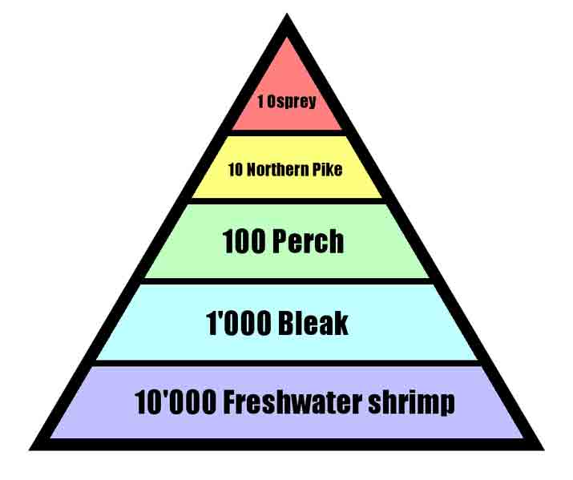
“Can a Jellyfish Unlock the Secret of Immortality?”
What is the one certainty of life?
- Death.
- What if that’s wrong?
What are Jellyfish?
- Radiata: include the Cnidaria and the Ctenophora.
  - Both of those C's are silent.
- Radiata have radial symmetry.
  - Their body plans are arranged around a center point.
Ctenophora:
- “Comb Jellies”.
  - Common! You WILL see them throughout the summer in New England waters.
- 1-10 cm in length.
- Largest animal to use cilia for moving.
- NO stinging cells.
  - You can touch them, eat them if you’re like Wally.
- Eat copepods and small fish, have a real gut.
Cnidaria:
- “Hydra”, “Jellyfish” “Box Jellies” “Sea Anemones” “Coral”.
- Most have two different body forms:
  - Sessile Polyp:
    - Sessile → does not move.
    - There are tentacles and a mouth “on top”.
  - Mobile Medusa:
    - Mobile → moves.
    - There are tentacles and a mouth “on the bottom.”
- Many exist only in one form or the other.
  - Corals → always a sessile polyp.
  - Jellyfish → always the medusa form.
- Others exist in both stages, over their life cycles:
  - Juvenile polyp stage.
  - Adult medusa form.
  - Sexual reproduction → production of sperm and egg.
  - Asexual reproduction → budding as a poly.
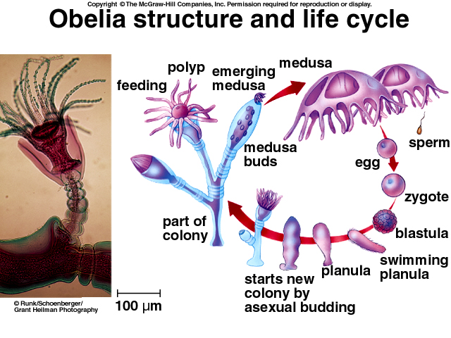
- Cnidaria DO HAVE stinging cells.
  - The cells are known as cnidoblasts.
    - These cells contain nematocysts → contains a discharge thread. When you trigger the outside trigger the nematocyst explodes out, releasing the discharge thread into whatever brush up against it.
- The Box Jelly:
  - One of the deadliest animals on earth.
    - They are found around Australia.
  - It is an active hunter (this is weird, and scary).
    - It stalks its prey with the aid of 24 fully functional eyes.
      - Eye clusters on each side of its “head” – they have two eyes with fully functioning retinas, corneas, and lenses.
        - Think human brown eye ball.
  - Carnivores.
  - They can be (including tentacles) ten feet to ten centimeters in length.
  - They can weigh 4 pounds.
  - Groups of jellies can be called fluthers of smacks.
  - Sea turtles are immune to the box’s jellies scary sting and eat them.
    - Save the turtles.
- The Hydra (Hydrozoans):
  - Typically, this is a stage of an organism's larger life cycle.
Turritopsis dohrnii: “The Immortal Jellyfish”
- It is very small → the size of a human pinky nail.
- Originally found in the Caribbean. Now, they are found all over the globe.
  - They are transported through ballast water in ships.
- Genetically all of the jellyfish appear to be genetic clones.
- Reversing the life cycle:
  - Transform from a Medusa into a Poly.
    - Backward.
  - If the jellyfish is faced with something bad (injured, diseased) instead of dying, it decides to go lie upon the seafloor. It will turn itself back into a poly and rest.
- It does not always happen:
  - They can die from old age.
  - They can be eaten.
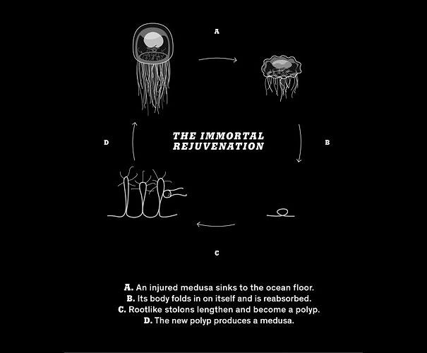
Cellular Transdifferentiation:
- There are two types of cells:
  - Somatic cells: and cell that forms the body of an organism.
  - Gametes: the sex cells (eggs and sperm).
Is this immortality?
- Not exactly → the cells are destroyed and new cells make a clone.
- But, it is very close, and a VERY strange thing.
Why do we Care?
- After all “it has no brains, for instance, nor a heart. It has a single orifice through which its food and wastes pass–in eats, in other words, out of its own anus.”
- The box jellyfish eyeball → super awesome.
  - How did the eye evolve? Did the eye evolve completely separate in all forms of life or collectively?
- The question of immortality.
- The medusa are similar to human's (genes).

